# Installation Guidelines

This guide contains guidelines for installing [IntelliJ IDEA](https://www.jetbrains.com/idea/download/#section=windows) and [JDK 11](https://www.oracle.com/technetwork/java/javase/downloads/jdk11-downloads-5066655.html).

## Install IntelliJ IDEA

Opening the above link starts downloading the IntelliJ IDEA 2020.2 installer. After we open the installation file, the following installation window is displayed:

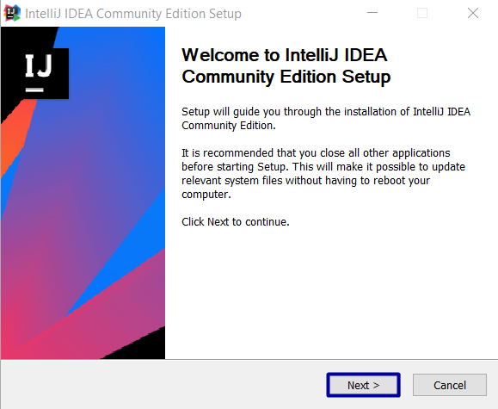

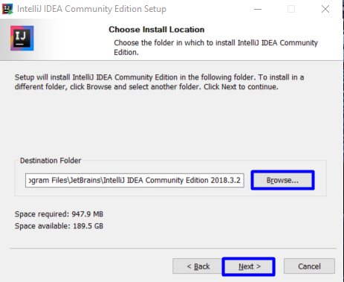

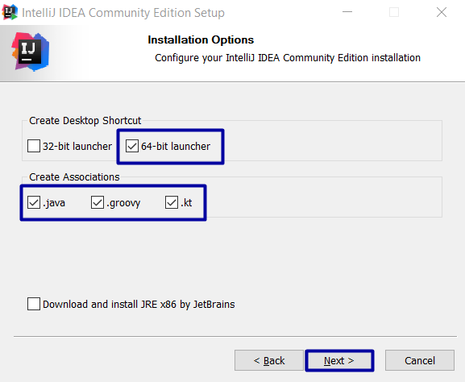

If you use 32 bit operation system, select "32-bit launcher" and then continue with next:

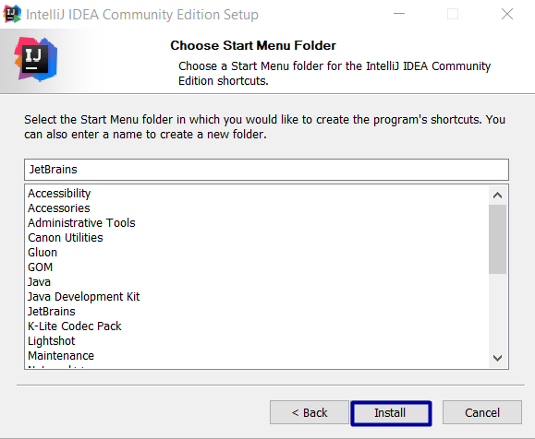

After installation, open IntelliJ IDEA.

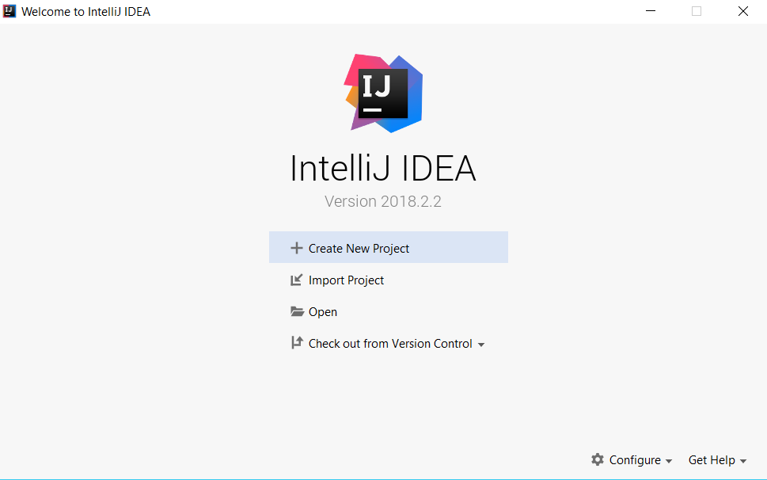

## Install Java SE Development Kit 11.0.1

To work with Java we need to install [**Java SE Development Kit - JDK 11.0.1**](https://www.oracle.com/technetwork/java/javase/downloads/jdk11-downloads-5066655.html)**.**   
When you click on the link we will see this:

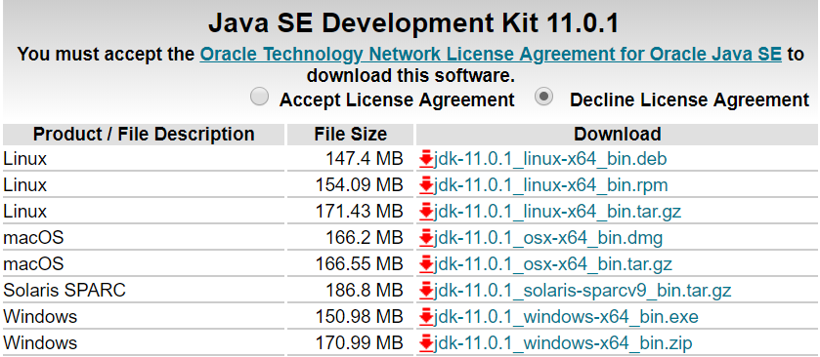

Check **"Accept License Agreement"** and choose the appropriate file according to your operation system.  
E.g **Windows 64-bit**:

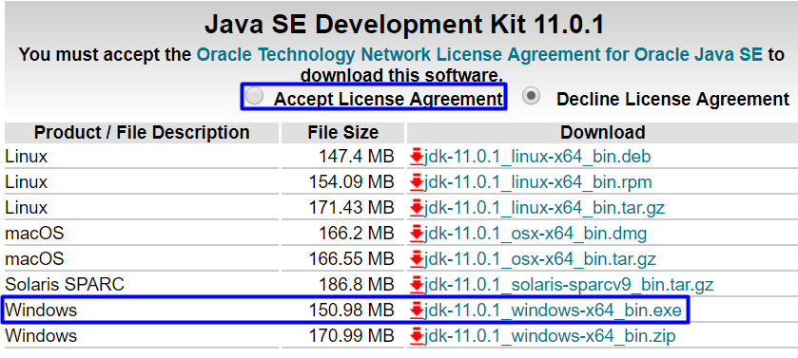

After download the file open it and click **"Next"**:

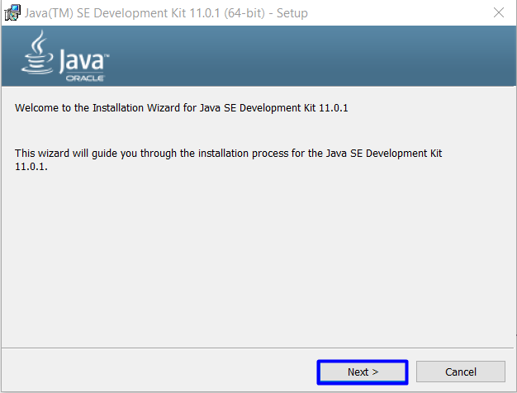

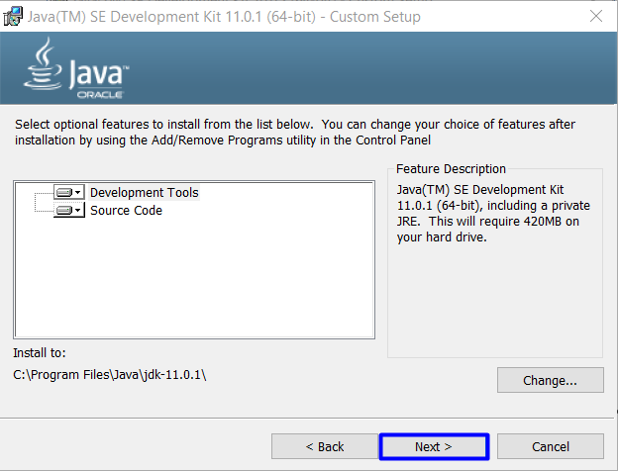

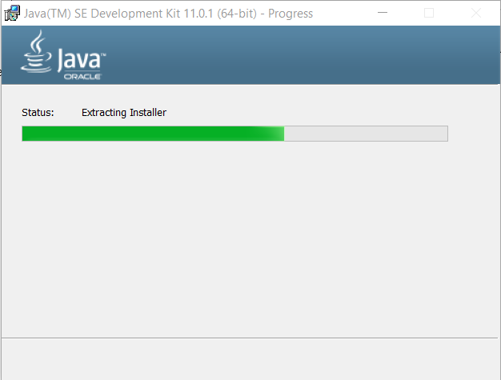

## Choose SDK 11

After the installation of **JDK** it is necessary to choose **SDK 11**. To do that click on **"Create New Project"**:

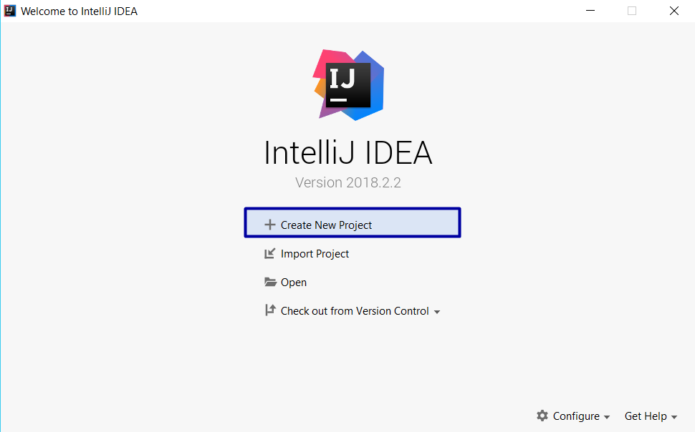

The displayed window in which we have to select the SDK from the already installed JDK package.   
By clicking the **"New"** button, select the package installation directory:

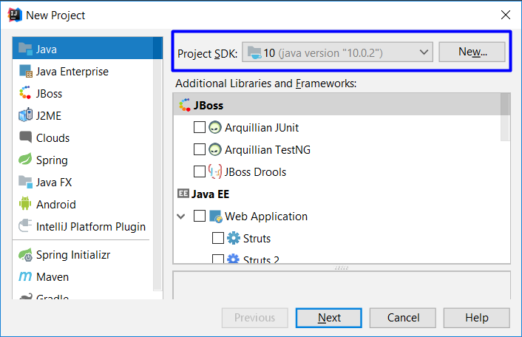

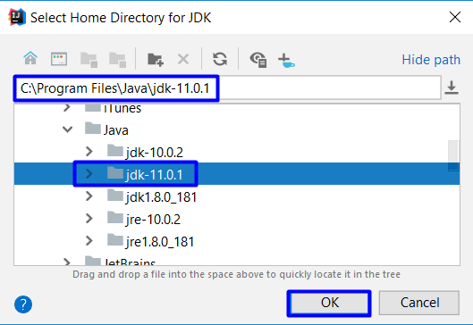

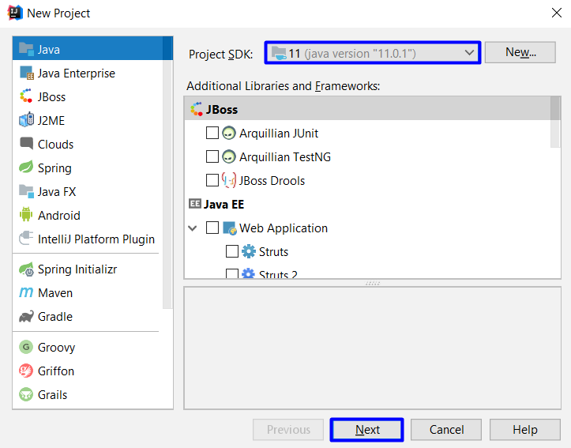

Select "**Java Command Line App**":

